**Assignment_6**

1.

Inner query:-

select salary from employees where employee_id=163;

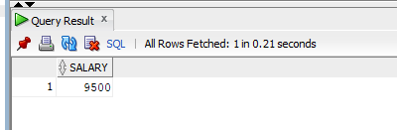

Sub Query:-

select first_name,last_name from employees where salary >(select salary from employees where employee_id=163);

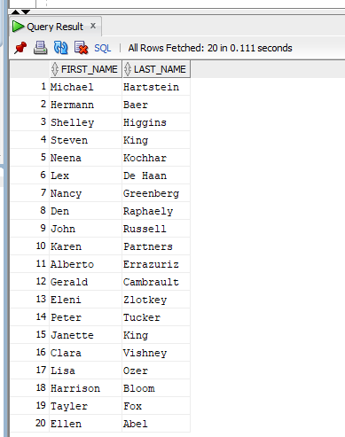

2.

select first_name,last_name,salary,department_id from employees e1 where salary=(select min(salary) from employees where department_id = e1.department_id);

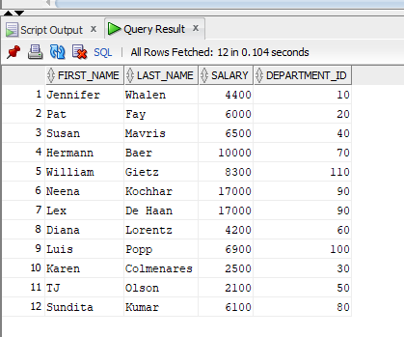

3.

select first_name,last_name,job_id,department_id from employees e1,dept d where e1.department_id=d.deptno and d.dname='finance' ;

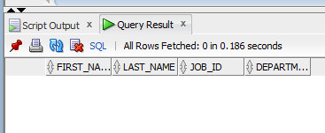

4.

Inner query:-

select employee_id from employees where salary=(select max(salary)from employees

where salary<(select max(salary) from employees))

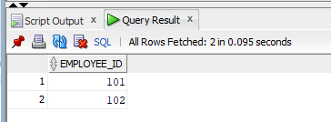

Sub query:-

select * from employees where employee_id in(select employee_id from employees where salary=(select max(salary)from employees

where salary<(select max(salary) from employees)));

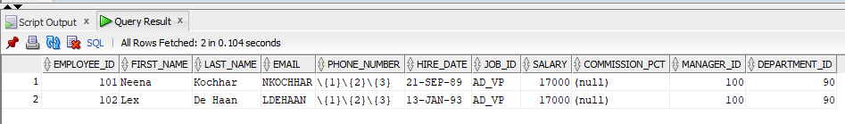

5.

select employee_id,first_name,last_name,salary from employees where salary>(select avg(salary) from employees) and

department_id in(select department_id from employees where first_name like '%j');

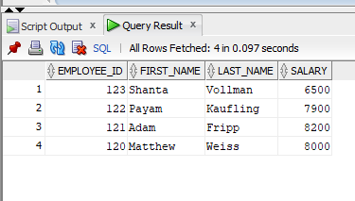

6.

Inner query:-

select salary from employees where job_id='MK_MAN'

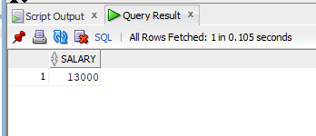

Sub query:-

select employee_id,first_name,last_name,job_id from employees where salary>any(select salary from employees where job_id='MK_MAN');

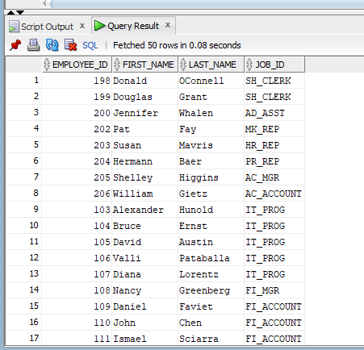

7.

Inner query:-

select salary from employees where salary>3700

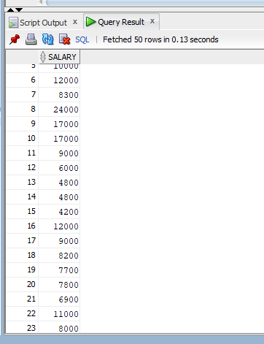

Sub query:-

select first_name,last_name from employees where salary in(select salary from employees where salary>3700);

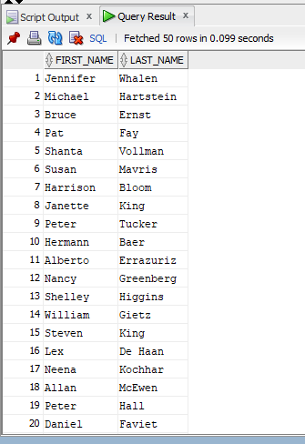

8.

select * from employees e where e.department_id=(select deptno from dept where loc='united kingdome');

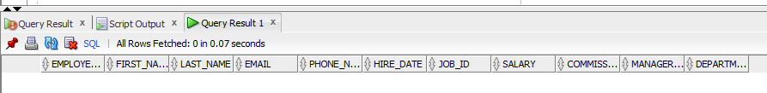

Using new York city:-

Inner query:-

select deptno from dept where loc='NEW YORK'

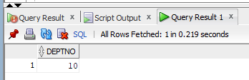

Sub query:-

select * from employees e where e.department_id=(select deptno from dept where loc='NEW YORK');

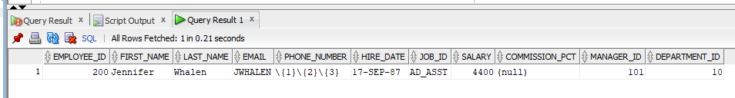

9.